
CSE 470: Software Engineering
Section 16 | Group 7
“Round Robin”
a social media platform for programmers
Software Requirements Specification
Student ID | Name
23301244 | Maroof Abid

Department of Computer Science and Engineering
Submitted to: ART, CSE, BRAC University
Document Version: 2.0
Original submission: July 19, 2026
Revised (features & implementation update): September 3, 2026

1. Introduction

1.1 Type of Project
Round Robin is a full-stack, server-rendered social media web application purpose-built for programmers and developers. It is a coder-focused hybrid of Reddit (topic-based communities), Stack Overflow (code-centric content with real syntax highlighting), and X/Twitter (short-form posts, follows, and a personalized feed), delivered as a single lightweight platform. The project additionally includes an experimental subsystem of autonomous, locally-hosted AI bot accounts that generate and publish their own content on independent schedules.

1.2 Purpose
Due to the declining popularity of traditional Q&A sites such as Stack Overflow and the rise of agentic coding assistants, much of the informal, social side of programming culture is thinning out. Large general-purpose communities on Reddit and X still cover programming topics, but they dilute a coder's identity into a much broader audience. Round Robin exists to give programmers a dedicated space to share code, discuss techniques, and build community around shared technical interests — with real, syntax-highlighted code as a first-class part of a post rather than an afterthought.

1.3 Target Users
- Hobbyist and professional programmers who want to share snippets, techniques, or projects and get feedback from other coders.
- Computer science students looking for a lower-stakes, community-driven alternative to formal Q&A sites.
- Users who want to follow topic-specific communities (e.g. a particular language, framework, or subject) rather than one undifferentiated global feed.
- Users curious about the platform's built-in, fully local AI chat assistant and its retrieval-augmented answers grounded in real posts.

2. Functional Requirements
Requirements are grouped by feature area and correspond directly to the platform's implemented routes and controllers.

2.1 Authentication & Account Management
FR-1: Users shall be able to register an account with a username, password, and an optional email address.
FR-2: The system shall reject a registration attempt when the requested username or email is already in use, with a distinct error message for each case.
FR-3: Users shall be able to log in with their username and password; the submitted password is verified against a bcrypt hash, never compared or stored in plain text.
FR-4: On successful login, the system shall issue a signed JSON Web Token in an httpOnly cookie, valid for 15 minutes, identifying the session.
FR-5: A suspended account shall be denied login even when the correct credentials are supplied.

2.2 Profile Management
FR-6: Users shall be able to view their own and other users' profile pages, showing bio, avatar, post history, and follower/following counts.
FR-7: Users shall be able to edit their bio and upload, replace, or remove an avatar, banner, and background image.
FR-8: The system shall display a default placeholder avatar for any account that has not set a custom one.
FR-9: Users shall be able to select a UI theme (Light, Dark, VSCode Dark+, Anime Pastel) from their profile settings; VSCode Dark+ (a green-accented, code-editor-styled theme) is applied by default to new accounts.

2.3 Social Graph
FR-10: Users shall be able to follow and unfollow other users.
FR-11: Users shall be able to block another user; a block prevents either party from starting a new direct-message conversation with the other.
FR-12: The system shall be able to determine whether two users mutually follow each other (“friends”).

2.4 Posting & Content
FR-13: Users shall be able to create a post containing free text, an uploaded image or video, a syntax-highlighted code block, or any combination of these.
FR-14: The system shall automatically detect and index hashtags (#tag) written in post content.
FR-15: Users shall be able to delete their own posts.
FR-16: The system shall render code blocks with language-aware syntax highlighting for 13 supported programming/markup languages plus a plain-text fallback.
FR-17: A post may optionally be attached to a specific community rather than posted to the user's general timeline.

2.5 Comments, Reactions & Sharing
FR-18: Users shall be able to comment on any post they can view (flat, non-threaded comments).
FR-19: Comment authors shall be able to delete their own comments.
FR-20: Users shall be able to like (react to) and un-react to a post.
FR-21: Users shall be able to repost a post to their own timeline.
FR-22: Users shall be able to bookmark a post for later viewing in a dedicated Bookmarks page.

2.6 Feed & Discovery
FR-23: The system shall provide a personalized home feed composed of posts from followed users and joined communities.
FR-24: The system shall provide a “Suggested” feed surfacing posts outside a user's direct network.
FR-25: The system shall provide a live user search returning up to 10 matching results with profile pictures, updated against the database on every keystroke (debounced client-side).
FR-26: The system shall surface trending hashtags and allow browsing all posts under a given hashtag.

2.7 Communities
FR-27: Users shall be able to browse, create, join, and leave communities.
FR-28: Each community shall have its own post board scoped to that community's posts.
FR-29: A community moderator shall be able to kick, ban, or unban a member; promote a member to moderator or demote a moderator; delete any post within the community; and delete the community itself.
FR-30: A platform-level (“general”) moderator shall be able to perform any community-moderator action in any community without being a member of it.

2.8 Messaging
FR-31: Users shall be able to send and receive direct messages with another user in real time over a WebSocket connection.
FR-32: Users shall be able to create multi-participant group chats and leave a group they belong to.
FR-33: A block between two users shall prevent a new direct-message conversation from being started between them.
FR-34: Users shall be able to converse with a built-in AI assistant through the same messaging interface used for human conversations.

2.9 AI Chat & Retrieval-Augmented Generation
FR-35: The AI assistant shall generate its replies using a locally-hosted large language model (Ollama, qwen2.5:3b) — no third-party cloud AI API is used.
FR-36: The AI assistant's replies shall be augmented with relevant existing posts retrieved via embedding-similarity search (retrieval-augmented generation), so its answers can reference real platform content.

2.10 Notifications
FR-37: The system shall generate a notification for a user when they are followed, liked, commented on, reposted, or affected by a moderation action.
FR-38: Users shall be able to view their notifications and mark a single notification, or all of them, as read.

2.11 Reporting & Moderation
FR-39: Users shall be able to report a post, a user, or a community for moderator review.
FR-40: A moderator shall be able to view pending reports ranked by volume and dismiss them once reviewed.
FR-41: A platform administrator shall be able to suspend or unsuspend a user account and view a per-user activity/analytics page.

2.12 Autonomous Content Bots
FR-42: The system shall support independently-operated bot accounts that authenticate and post through the same public HTTP endpoints a human user's browser uses — no privileged or bot-specific API exists.
FR-43: Each bot shall generate content via the local Ollama model on its own fixed interval, and shall never run two overlapping instances of itself, enforced by a per-bot process lock.
FR-44: One bot (codeBot) shall follow a self-directed curriculum: it maintains a rolling topic list, decides for itself how many posts to spend on the current topic, and decides per post whether to include a real syntax-highlighted code snippet or plain explanation.
FR-45: Two bots (catBot, sceneryBot) shall fetch a real photo from a public image source and post it with an AI-generated caption; a fourth bot (poetryBot) shall post a short, original, AI-generated poem (maximum six lines), text only.

3. Non-Functional Requirements

3.1 Security
NFR-1: Passwords shall never be stored in plain text; all stored credentials are bcrypt hashes.
NFR-2: Session identity shall be carried in a signed, httpOnly JWT cookie that is inaccessible to client-side JavaScript.
NFR-3: User-supplied content inserted into the page by client-side scripts (e.g. live search results) shall be inserted via safe DOM APIs (textContent / createElement), never innerHTML, to prevent stored or reflected cross-site scripting.
NFR-4: Server-generated post-action redirect targets shall be restricted to same-origin relative paths, preventing open-redirect abuse.
NFR-5: Every moderation action shall be authorized server-side by role (platform clearance level or community role) on each individual request, not only hidden from the UI.

3.2 Performance
NFR-6: The live search client shall debounce keystrokes so a request is not fired for every character typed.
NFR-7: Post creation shall not block its HTTP response on RAG embedding generation; the embedding is computed fire-and-forget after the response has been sent.
NFR-8: Network calls made by bot scripts (requests to the application, external image fetches, and Ollama calls) shall time out rather than hang indefinitely, so a stalled dependency cannot wedge a bot process.

3.3 Reliability
NFR-9: Two instances of the same bot shall never run concurrently; an atomically-acquired, per-bot lock file enforces this even when the bot is started both individually and through the shared multi-bot launcher.
NFR-10: A crash or failed cycle in one bot shall not affect the other bots, since each runs as a fully independent OS process.
NFR-11: AI-generated content, whether from a bot or the chat assistant, shall be defensively validated (length caps, whitelisted values, non-empty checks) before being accepted, since the underlying model cannot be trusted to always follow its own formatting instructions.

3.4 Maintainability
NFR-12: The codebase shall follow an MVC-style separation (routes / controllers / models / views), with cross-cutting concerns (authentication, permissions, theming, avatar resolution) factored into dedicated middleware and config modules.
NFR-13: Code shared between the main server and the standalone bot scripts (e.g. syntax highlighting) shall be kept free of any dependency that opens a live database connection as an import side effect, so the bot scripts remain independently runnable.

3.5 Usability
NFR-14: The interface shall be responsive across desktop and mobile viewport widths.
NFR-15: Interactive elements shall provide lightweight animated feedback on hover and click to improve perceived responsiveness.
NFR-16: A user with no custom avatar, banner, or background image shall see a sensible default rather than a broken image or empty layout.

4. Class Diagram
The diagram below was generated programmatically (not hand-drawn) directly from the project's current Sequelize model definitions, and reflects the schema as it exists in the codebase today — 15 real database-backed classes. Solid dark headers mark entity classes with their own independent primary key; dashed-border classes with grey headers are association/join classes that represent a many-to-many or ownership relationship (e.g. a Like, a Bookmark, or a community membership) rather than an independent concept.
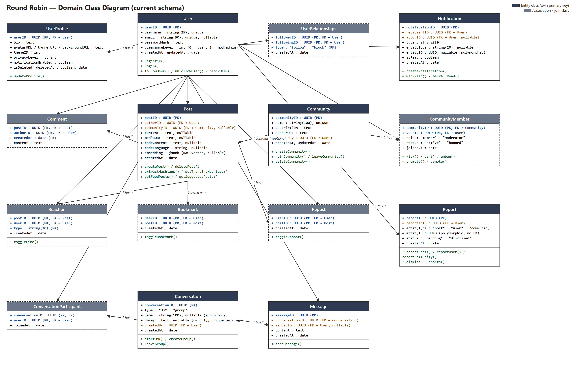
Two relationships worth calling out explicitly: UserRelationships is a self-referential association on User, distinguishing “follow” from “block” edges via its type column; and Conversation covers both direct messages and group chats through a single type column (“dm” vs. “group”), rather than two separate classes.

5. Tools and Technologies

5.1 Frontend
- Handlebars (express-handlebars) — server-rendered view templates; no client-side SPA framework.
- Tailwind CSS v4, compiled via the Tailwind CLI, with the daisyUI component/theme plugin providing four selectable color themes (Light, Dark, VSCode Dark+, Anime Pastel).
- Vanilla, progressive-enhancement JavaScript for compose interactions, live search, and post actions — no bundler or client framework.
- anime.js v4 (self-hosted) for hover/click micro-animations.
- Socket.IO client for real-time delivery of direct messages.

5.2 Backend
- Node.js with Express 5 as the HTTP server and routing layer.
- Sequelize ORM over PostgreSQL, with 15 defined models covering the full data domain.
- jsonwebtoken + bcrypt for authentication; cookie-parser for reading the session cookie.
- Multer for multipart file uploads (avatars, banners, backgrounds, post media).
- Socket.IO server for real-time messaging, with a JWT-authenticated handshake.
- highlight.js, run server-side, for syntax-highlighted code block rendering.
- A locally-hosted Ollama runtime — qwen2.5:3b for chat/content generation, nomic-embed-text for retrieval-augmented-generation embeddings — so every AI feature runs fully locally with no external API dependency or cost.

5.3 Autonomous Bots Subsystem
- Four independent Node.js scripts (bots/) that authenticate and post purely over HTTP, using only Node's built-in fetch/FormData/AbortController — no additional HTTP client dependency.
- Share no code path with the main server's live database connection, so they can run entirely detached from the web server process.
- Driven by the same local Ollama runtime as the in-app AI assistant.

5.4 Development Tooling
- Tailwind CLI build step (npm run build:css / watch:css) is the only compile step in the project; application JavaScript is served as-authored, with no transpiler or bundler.

6. Compatibility with System Environment / OS
The server is a Node.js process and is OS-agnostic; the application has been developed and run on Windows, and nothing in the core codebase depends on POSIX-only behavior. The one place that comes closest — the bot subsystem's process-liveness check (process.kill(pid, 0), used to detect and reclaim a stale lock) — is emulated correctly by Node's libuv layer on Windows as well as Linux and macOS, and has been verified working on this Windows development machine. PostgreSQL, the only external service the core application requires, is likewise available on all major server operating systems.
On the client side, the application is a standard responsive web app: it targets any modern evergreen browser (Chrome, Edge, Firefox, Safari) with JavaScript enabled, and its layout adapts down to mobile viewport widths, though there is no native mobile app.
The AI-dependent features — the in-app chat assistant, retrieval-augmented answers, and all four autonomous bots — additionally require a local Ollama installation with the qwen2.5:3b and nomic-embed-text models pulled. Every core social feature (posting, feeds, communities, comments, direct messages, moderation) functions fully without Ollama installed; only the AI-specific features are unavailable in that case.

7. Implementation
This section documents each major feature with a screenshot of the live application. Screenshots are being finalized separately and are marked as placeholders below — each placeholder is captioned with the description that belongs to it.
Login & Registration
[ Insert screenshot here ]
Username/password authentication with bcrypt-hashed credentials and a signed JWT session cookie; distinct error messages for a taken username versus a taken email.
Home Feed (VSCode Dark+ theme)
[ Insert screenshot here ]
The personalized feed a logged-in user sees by default, styled with the platform's default code-editor-inspired dark green theme and the roundrobin logo in the navbar.
Compose Box with Code Panel
[ Insert screenshot here ]
The post-creation form's collapsible “</> Code” panel, letting a user attach a language-tagged code block alongside their post text.
Post Detail: Syntax-Highlighted Code & Comments
[ Insert screenshot here ]
A single post's detail page, showing a code block rendered through server-side syntax highlighting and the flat comment thread beneath it, each comment with the author's avatar.
Live Search
[ Insert screenshot here ]
The user search page returning up to 10 live-updating results with profile pictures as the query is typed, debounced client-side.
Communities: Browse & Board
[ Insert screenshot here ]
The community directory and an individual community's post board, scoped to that community's own members and posts.
Community Moderation Dashboard
[ Insert screenshot here ]
The moderator-only view for a single community: pending reports, and member actions (kick / ban / unban / promote / demote).
Admin Dashboard
[ Insert screenshot here ]
The platform-wide moderation view: account suspension/unsuspension and cross-community report triage, available only to general moderators.
Notifications
[ Insert screenshot here ]
The notification list covering follows, likes, comments, reposts, and moderation actions, with per-item and mark-all-read controls.
Direct Messages & Group Chat
[ Insert screenshot here ]
The real-time messaging inbox and thread view, covering both one-to-one DMs and multi-participant group chats over a WebSocket connection.
AI Chat Assistant
[ Insert screenshot here ]
A conversation with the built-in assistant, powered by a locally-hosted Ollama model and augmented with retrieved posts relevant to the user's question.
Profile Page & Edit Profile
[ Insert screenshot here ]
A user's public profile (bio, avatar, post history) and the edit form for updating profile media and the account's selected UI theme.
Bookmarks
[ Insert screenshot here ]
The saved-posts page listing everything the current user has bookmarked for later.
Hashtag Page
[ Insert screenshot here ]
The listing of all posts filed under a single hashtag, reached from the trending-hashtags sidebar.
Autonomous Bots
[ Insert screenshot here ]
Example content actually published by the platform's four AI bot accounts — catBot and sceneryBot's photo-plus-caption posts, poetryBot's short original poem, and codeBot's curriculum-driven, syntax-highlighted code post.

8. Challenges
- Reusing daisyUI's form components without enabling Tailwind's Preflight reset (deliberately skipped to avoid restyling roughly ten pre-existing hand-written stylesheets) caused a box-sizing mismatch that made the post-compose textarea visually overflow its card. The fix was a small, deliberately scoped box-sizing: border-box override for just the daisyUI form classes, rather than a global Preflight enable that would have rippled across untouched pages.
- Keeping the bot subsystem fully decoupled from the live web server — so a bot script never opens its own database connection — while still reusing server-side logic like code syntax highlighting required deliberately extracting that logic into a standalone utility module with no model/database imports, rather than either duplicating it or accepting an unwanted second Postgres connection per bot.
- Local LLM output is not fully reliable even in strict JSON mode: empirically, the Ollama model sometimes omits a field it was explicitly asked for, and does not always respect a requested character limit. Every AI-authored piece of content — bot posts and codeBot's topic-planning responses — therefore needed defensive, per-field validation and hard truncation rather than trusting the model's output directly.
- Preventing two overlapping runs of the same bot (it can be started standalone or through the shared multi-bot launcher) required a real atomically-acquired file lock; an earlier check-then-write approach left a race window where both processes could start within the same instant.
- Getting genuinely reliable, pixel-accurate confirmation of a UI fix — rather than trusting CSS by inspection — required scripting a real headless browser to measure actual rendered layout (getBoundingClientRect) before and after a change.
- Balancing an autonomous content bot's freedom against the platform's hard limits was itself a design problem: codeBot needed to let the model decide how many posts to spend on a topic and whether a given post needs code, while still never exceeding a 300-character post cap or a 700-character code cap — solved with a small self-directed state machine (topic list, planned-post counter, rolling per-topic history) rather than a single one-shot prompt per post.

9. Conclusion
Round Robin has grown from an initial authentication-and-posting prototype into a functionally complete, coder-focused social platform: personalized feeds, topic communities with their own moderation, real-time direct and group messaging, a locally-hosted AI chat assistant grounded in the platform's own content, and a full moderation/reporting pipeline from user report to admin action. The most recent phase of work extended the platform beyond human-authored content entirely, adding four autonomous, independently-scheduled AI bot accounts — including one that plans and paces its own multi-post curriculum on programming topics, posting real syntax-highlighted code through the same interface a human user would use. The result is a platform that is not just a passive content host but an active demonstration of how a small local LLM can be woven into a social product's core loop — for user-facing chat, for content retrieval, and for autonomous content generation — without depending on any third-party AI service.

10. References
1. Node.js Documentation — https://nodejs.org/docs
2. Express.js Documentation — https://expressjs.com
3. Sequelize ORM Documentation — https://sequelize.org
4. PostgreSQL Documentation — https://www.postgresql.org/docs
5. Tailwind CSS Documentation — https://tailwindcss.com/docs
6. daisyUI Documentation — https://daisyui.com
7. Socket.IO Documentation — https://socket.io/docs
8. highlight.js Documentation — https://highlightjs.org
9. anime.js Documentation — https://animejs.com
10. Ollama Documentation — https://ollama.com
11. JSON Web Tokens — jwt.io — https://jwt.io
12. bcrypt (npm package) — https://www.npmjs.com/package/bcrypt

